AI-Driven Personalisation in Digital Marketing: Balancing Innovation and Consumer Privacy

ABSTRACT
Artificial intelligence (AI)-driven personalisation is reshaping digital marketing by enabling hyper-targeted experiences, but it also intensifies privacy concerns and ethical dilemmas. This systematic review examines the interaction between AI-enabled marketing and consumer trust, algorithmic transparency, and ethical governance, drawing on 41 peer-reviewed studies published between 2014 and 2025. The review employs thematic synthesis to extract five key thematic domains: the trust-personalisation paradox, explainability in AI systems, ethical governance, consumer empowerment, and future research trajectories. Findings reveal that although AI personalisation enhances engagement and perceived relevance, it often lacks transparent mechanisms and clear ethical boundaries, thereby eroding user trust. Empirical evidence suggests that permission-based targeting, explainable AI, and consumer-controlled data frameworks are emerging as best practices, although they are rarely adopted systematically. Gaps remain in the operationalisation of ethical AI, particularly across cultural contexts and long-term behavioural outcomes. The review concludes that ethical AI marketing must prioritise user empowerment, institutionalise transparency, and position ethical governance as a strategic asset in digital engagement.

GENERAL TERMS
Artificial Intelligence, Digital Marketing, Data Privacy, Ethics, Machine Learning, Consumer Behaviour

KEYWORDS
AI Personalisation, Predictive Analytics, Algorithmic Transparency, Federated Learning, Consumer Trust

1 INTRODUCTION
The paradigm of digital marketing has been redefined with the understanding of Artificial Intelligence (AI), which transforms information into actionable consumer insights and enables the delivery of a perfectly personalized experience on platforms [1]. The post-pandemic economy is characterised by a continued increase in the use of AI-based personalisation to maintain engagement, maximise return on investment (ROI), and handle real-time interactions with consumers [1, 2]. The marketing automation market is projected to reach USD 72 billion by 2026, with predictive analytics and recommendation algorithms poised to replace the creativity of intuition, marking a pivotal point in using data to guide decisions [3]. With the refinement of advertisements and content based on behavioural traces, algorithms can also raise ethical concerns about the constant surveillance of data and the ambiguity of algorithmic decision-making [4]. Currently, the marketing industry is facing a paradox because AI personalisation makes it more competitive, while also challenging the limits of consumer privacy and trust in the digital world.
Personalisation, which AI fuels, can be described as the calculation that involves learning patterns, settings, and purpose to fine-tune digital communication at the personal level [5]. The systems combine monitored and unmonitored segmentation, contextual prediction, and adaptive deliveries of messages [4; 6]. Consumer privacy, on the other hand, refers to the right of individuals to control how their personal data is collected, processed, and used in business environments [7; 8]. In cases where predictive analytics and personal data intersect, concerns arise regarding informed consent, data provenance, and the re-identification of anonymised datasets [3]. The concept of algorithmic transparency, or the ability to understand how automated systems arrive at their outputs, has thus become an ethical concern among participants in digital marketing [9].
Even though hyper-personalisation positively impacts the business operations, the world experience demonstrates that customers feel unsatisfied with the exploitation of information. The polls conducted throughout the European Union indicate that 63% of users are worried about losing control over their personal data, and 58% of them do not trust the recommendation algorithm based on behavioural profiling [10]. Laws like the General Data Protection Regulation (GDPR) (2018) and other more recent laws, like the EU Artificial Intelligence Act (2024), establish a sense of accountability and privacy-by-design practices, but their enforcement is still fragmented across countries [8; 9; 11]. As such, marketers are in a business environment where any innovation that enhances the predictive accuracy also increases the risks of ethical non-adaptation [12]. This imbalance between technological ambition and regulatory maturity defines the central tension explored in this study.
The existing literature has valuable by incomplete perspectives. Marketing analytics is notably biased toward performance metrics, such as conversion rates, engagement, and ROI, and not the ethical and social consequences of algorithmic decision-making [13]. Information systems and computer science research have investigated the approaches to reducing algorithmic fairness and minimising bias, but do not often consider the psychology of consumers or trust development in marketing [14]. On the other hand, business ethics as an academic discipline draws attention to privacy and autonomy but fails to acknowledge the commercial forces that are pushing companies towards hyper-personalisation [3; 8]. This disintegration shows the lack of a coherent framework that would be able to balance out innovation and the maintenance of privacy. As such, the insights provided in this paper combine results obtained in the fields of marketing, information systems ethics, and consumer behaviour research to create a comprehensive model of responsible AI personalisation.
This study aims to analyse how AI-driven personalisation in digital marketing can balance innovation with consumer privacy protection. Driven by this aim, the study pursues four objectives (1) to examine state-of-the-art AI personalisation mechanisms and their contribution to marketing innovation; (2) to evaluate ethical and regulatory challenges arising from data-intensive marketing; (3) to identify and synthesise organisational strategies that align transparency with compliance. Based on these objectives, the research questions are the following: How does AI-driven personalisation transform marketing practice? What ethical and privacy risks accompany this transformation? Which managerial and technical strategies can enable responsible personalisation that maintains consumer trust?
This study has three significances. First, it extends marketing theory by integrating the Technology Acceptance Model with emerging frameworks of algorithmic-accountability and digital-ethics governance. The second is on a managerial level, which provides practitioners with techniques of imbuing transparency, fairness, and consent in the routine marketing practice. On a societal level, the third importance is that it educates the regulators and policymakers about how the ethical adoption of AI can save autonomy for consumers and, at the same time, ensure market efficiency.
The rest of this paper continues as follows. Section 2 provides a literature review of the existing studies of AI-driven personalisation, data ethics, and privacy governance. Section 3 presents the conceptual framework, which correlates innovation, privacy, and trust. Section 4 describes the integrative systematic review methodology. Section 5 contains thematic findings. Section 6 contains a discussion of the implications for theory, management, and regulation. Section 7 wraps up the paper with a summary of contributions and future research directions.

2 LITERATURE REVIEW

2.1 Evolution of AI-Driven Personalisation
Artificial intelligence has moved digital marketing out of crass, rules-of-thumb segmentation to adaptive personalisation that predicts personal intent in near real time. Initial engines were based upon deterministic if-then rules and fixed demographics, which were not able to cope with thin data and context-change [15]. Machine learning has facilitated the identification of patterns in high-dimensional signals, including clickstream paths, dwell time, and simple text features, enhancing the selection of the next-best-action and content fit [7; 16]. In deep learning, they learned nonlinear correlation between heterogeneous inputs, such as image frames, longer texts, and sequences of sessions, so suggestions and offers were based on subtle preference dynamics, but not on co-occurrence [17]. This transferred AI to the heart of orchestration of customer experience across retail, media, and travel, combining targeting, pricing hints, and creative variation [13]. Expertise in experimentation also evolved in the same direction: offline uplift modelling shapes online A/B routing, and feedback loops update segments in constantly evolving manners, increasing baseline engagement and decreasing campaign cycle time [7].
Modern personalisation is more than “people like you also viewed” to contextual systems and sequence-conscious systems which respond to micro-events by adjusting message, creative, and timing across channels [5]. Reinforcement learning trades exploration against exploitation to maximise long-horizon value, whereas sequence models trade copy against creativity to the point of the path, as opposed to the single click [18]. Multimodal pipelines combine text, image, and audio inputs and can support fine-grained creative swaps and dynamic layouts, both of which are trained to be assessed based on their expected utility instead of rules of thumb [6;15]. Nevertheless, researchers observe that these benefits are associated with increased data reliance and model obscurity, making informed consent, provenance tracking, and meaningful explanation to consumers and auditors difficult [19;20]. This historical development of deterministic segmentation into learning systems makes it clear why the maximisation of relevance and the enhancement of ethical complexity are now two sides of a coin: transparency, accountability, and acceptable use of data are raised by the same architectures, which maximise relevance.
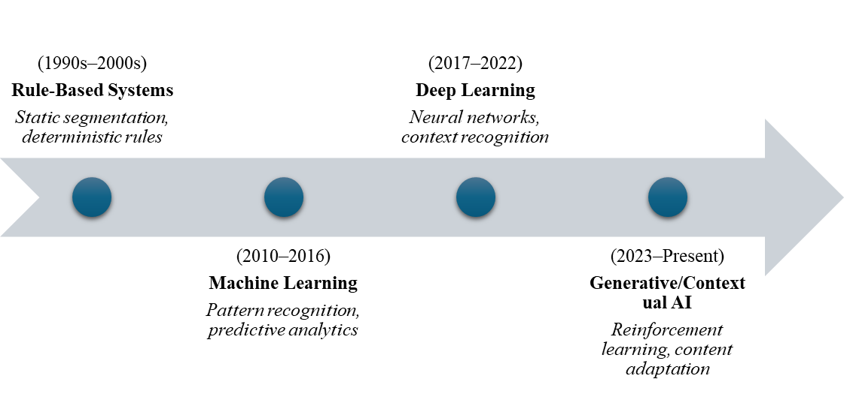
Fig 1: Timeline of AI-Driven Personalisation Evolution (Source: Author, 2025)

2.2 Consumer Privacy and Data Protection Challenges
The growth of AI-based personalisation is significantly dependent on the collection of large-scale data based on the histories of browsing, device identifiers, and cross-platform interactions. Improved tracking systems, including cookies, web pixels, geolocation beacons, and sentiment analysis, allow companies to create a detailed behavioural profile that can help forecast consumer intent with accuracy [4]. Although such datasets can lead to more efficient recommendations, they also subject people to constant surveillance and commodification of data, which can be described as surveillance capitalism [21]. The ongoing user information movement in digital ecosystems increases the danger of unauthorised information sharing and data assaults, especially when algorithms are instructed by third-party or inferred information [16]. Recent research indicates that the issue of privacy has become a major determinant of the disclosure readiness of consumers, which directly affects the level of engagement and purchase intention [22]. As a result, the conflict between utility and autonomy is the heart of contemporary digital-ethics discussions, which places consumer trust as a moral as well as a competitive resource [7; 11]. The data-protection flow within AI marketing systems can be conceptualised as a cyclical framework of risk identification, mitigation, and continuous governance (see Fig. 2).
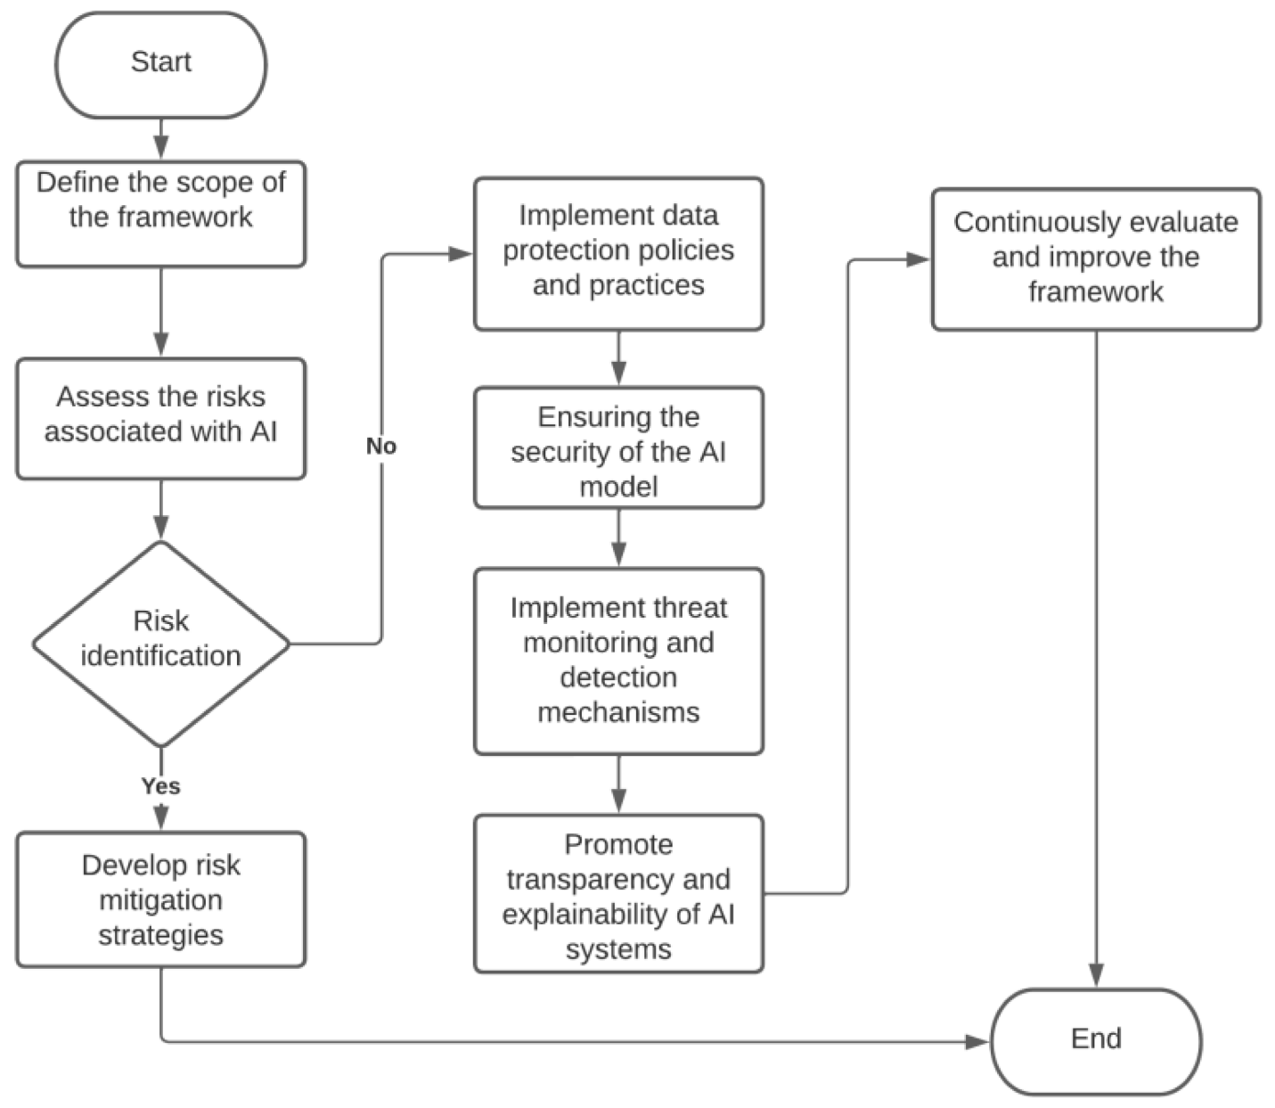
Fig. 2. AI Personalisation Data-Protection and Risk-Mitigation Framework
Source: Adapted from ‘Privacy in Artificial Intelligence System’ Villegas-Ch and Garcia-Ortiz [29]
Regulatory agencies and governments have reacted by providing systems to address data ethics and consumer rights. Consent, purpose limitation, and minimisation, which had been codified by the General Data Protection Regulation as well as transparency and opt-out privileges provided under the California Consumer Privacy Act, became the established basis of these rights in the U.S. and the United Kingdom, respectively [24]. Additionally, more recently, artificial intelligence is presented in the European Union Artificial Intelligence Act, which suggests risk-based classification of AI uses and requires, among other things, that an algorithm is accountable and controlled by people [25]. Even with such legal progress, the application of the given laws does not have a uniform pattern across the jurisdictions, which means that cross-border data flows and automated-decision liability remain ambiguous [12; 19]. According to recent research findings, operational compliance should be integrated to incorporate technical defenses, such as federated learning and differential privacy, into marketing systems, rather than relying on post-hoc compliance [12; 26; 27; 28]. Hence, the protection of consumer data by enhancing their security necessitates an interplay between ethical design, transparent governance, and active auditing of algorithms.

2.3 Ethical and Socio-Psychological Dimensions
The algorithms of AI-driven personalization have reignited long-standing ethical debates over autonomy, consent, and the scope of control in digital marketing [30]. Predictive systems that are able to implicitly infer intent and shape exposure can influence behaviour in a subtle manner, which is worrisome due to the possibility of nudging behaviour without realisation [18]. This type of algorithmic persuasion blurs the lines between free will and commercial influence, undermining cognitive autonomy and fairness [9; 12]. Their decision-making agency reduces as they are modelled as continuous behavioural subjects and as producers of data at the same time [21]. The privacy issue is not isolated (it is also a moral responsibility issue), to make persuasion evident and choice-conserving [16]. This tension is visualised as the deontological duty opposed to utilitarian welfare in Fig. 3, which reveals how efficiency can, without ethical restraints, become exploitive marketing or forceful persuasion.

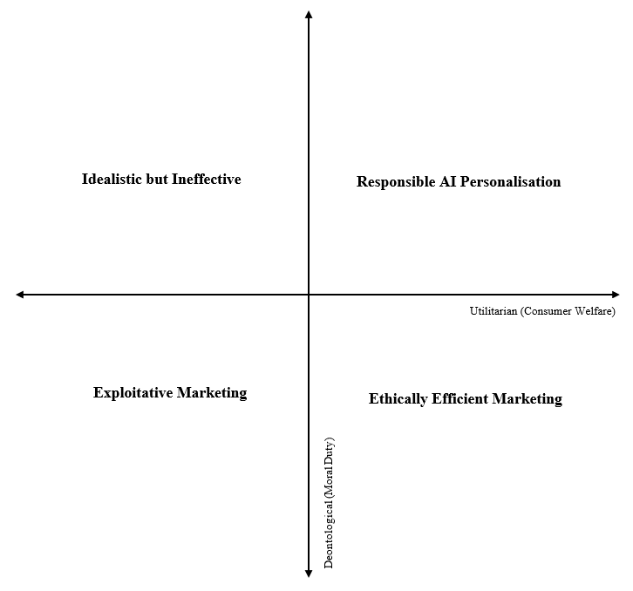
Fig. 3. Ethical Tension Map between Utilitarian and Deontological Marketing Practices (Source: Author, 2025).
The framework provided in Fig. 4 - Ethical Tension Map between Utilitarian and Deontological Marketing Practices illustrates an equilibrium between the rule-based and outcome-based moral on the part of the marketer. The optimal alignment, which is the best-case scenario in the hierarchy of the two approaches to AI personalisation, is the top-right quadrant, Responsible AI Personalisation. The bottom-left, Exploitative Marketing, denotes the situation where data are manipulated through weaponisation, which is the side of the box that demonstrates the failure of ethics. Between these extremes are the Idealistic yet Ineffective strategies, which involve extremes of moral caution, and Ethically Efficient Marketing, wherein gains to welfare are made but not accompanied by transparency [18]. This mapping highlights that ethical maturity requires a balance - balancing algorithmic efficiency and duty-bound governance [19]. Psychological studies also indicate resilience to privacy and despondency, in which users forego privacy in favour of convenience even though they do not trust it [31]. In this respect, therefore, authentic trust can only be promoted not just by complying with a set of rules, but also by a moral design that balances persuasion with respect for human autonomy.

2.4 Algorithmic Transparency and Accountability
Transparency algorithms have made the foundation of ethical governance in the AI-based marketing systems [1]. As algorithms increasingly determine which content consumers watch and buy, the lack of access to their inner workings fuels suspicion and speculation about manipulation [5]. Explainable Artificial Intelligence (XAI) is an effort to overcome this problem by providing human-readable explanations for why a machine made a particular choice [8]. In digital marketing, transparency is used to boost consumer confidence by explaining why certain recommendations or advertisements are displayed, thereby reducing the fear of being persuaded unknowingly [16]. On the other hand, convenience is turned into an ethical risk by the lack of transparency, as consumers do not understand whether personalization is truly useful or just another commercial trick [9]. Accountability on algorithms is not merely a matter of disclosing code; thus, it is a strategic move to protect brand integrity and trust in the data-intensive marketing space [20; 24].
Transparency should also be accompanied by accountability mechanisms that create specific responsibility with respect to algorithmic results [1; 5]. They are routine checks, equity measures, and autonomous control to identify discrimination or privacy breaches throughout the AI lifecycle [19]. According to critics, accountability has to be institutionalised, and multidisciplinary governance has to be established, involving a union of marketers, computer scientists, and legal professionals [32]. The Transparency-Accountability Continuum, as illustrated in Fig. 4, shows how AI marketing systems increase from opaque automation to explainable and managed architectures. Each stage is a step to consumer understanding, moral learning, and long-term trust in the population. Linking the concepts of transparency and governance, companies will turn possible scepticism into trust, developing the culture of responsible innovation that will bring commercial prosperity into compliance with moral and regulatory demands [28].
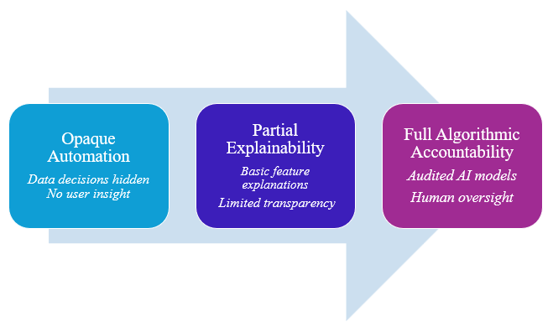
Fig. 4. Transparency–Accountability Continuum in AI-Driven Marketing Systems (Source: Author, 2025).

2.5 Privacy-Enhancing and Regulatory-Compliant Techniques
One way to reconcile AI personalisation and ethical and regulatory requirements is through the development of privacy-enhancing technologies (PETs) [5]. One of such methods is known as federated learning, which enables models to be trained on multiple devices or servers without the need to transfer the raw user data, which reduces the exposure to privacy risks [2]. Practically, similar organizations as Google and Apple have chosen federated architectures to predictive text and recommendation systems, keeping sensitive information on-device, and combining it with global model performance [33]. This is supplemented by differential privacy that introduces mathematical noise to the datasets and does not encourage individual re-identification, without losing statistical accuracy [34]. Combined, these technologies can demonstrate how innovation can be in line with compliance within the provisions of the GDPR, as well as the EU AI Act, which require data minimisation, transparency of consent, and accountability in the entire automated-decision pipelines [23; 24; 25].

Even though they have the potential, privacy-enhancing techniques have implementation and governance issues [15]. Federated learning is intensive in regard to computation power, whereas differential privacy may affect accuracy when applied excessively with noise [29; 33]. Hence, organisations are to balance utility and privacy protection by introducing adaptive thresholds and strong encryption algorithms. The interaction is shown in Figure 5, illustrating how PETs boost regulatory compliance through a privacy-by-design at every level of AI marketing processes: the acquisition and training of the model, its deployment and feedback mechanisms. It is also required to integrate effectively that necessitates cross-functional control in which the legal, ethical and technical professionals evaluate the effects of privacy together [12]. This man-machine relationship transforms compliance into a competitive edge, proving that the preservation of information integrity increases consumer confidence and company resistance in the AI-based market [19].
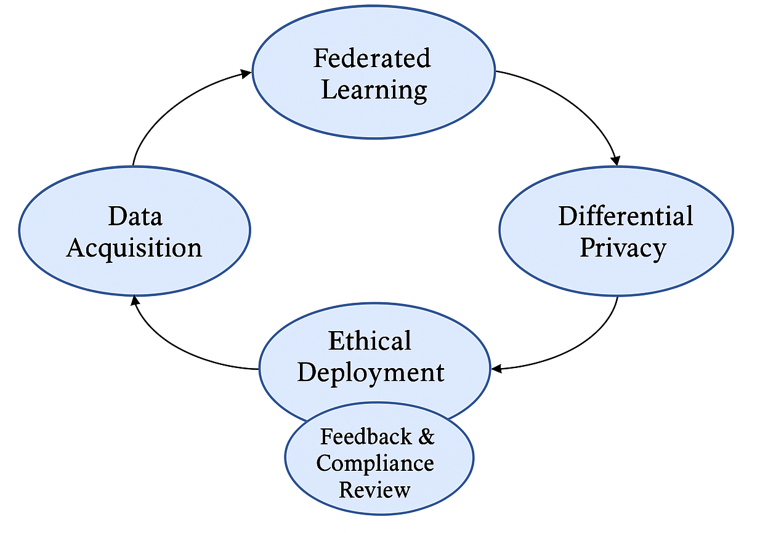
Fig. 5. Privacy-Enhancing and Regulatory-Compliant Techniques in AI-Driven Marketing Systems (Source: Author, 2025).

3. METHODOLOGY
This study employs the Systematic Literature Review (SLR) method and aims to consolidate inconsistent findings on the subject of artificial intelligence (AI)-based personalisation and consumer privacy in digital marketing. The SLR approach provides a clear and repeatable method for locating, assessing, and synthesising data from previous studies [35; 36]. It enables the systematic integration of multidisciplinary perspectives on marketing innovation, data ethics, and algorithmic governance. Using the PRISMA 2020 principles of gathering peer-reviewed scholarly articles [37], this review will systematically search peer-reviewed academic publications published between 2014 and 2025 that discuss AI personalisation, data protection, or algorithmic transparency. The choice of a systematic approach guarantees methodological rigour, reduces the researcher's bias, and helps identify the primary conceptual patterns, theoretical frames, and gaps in the research. This design thus helps to evidence-based knowledge on how AI innovation can coexist with ethical and privacy-friendly marketing practices.

3.1 Review Questions
The Systematic review has particular research questions that govern the database search, inclusion and exclusion processes, and the overall selection of relevant literature. As it has been mentioned above, the aim of this study is to analyse how AI-driven personalisation in digital marketing can balance innovation with consumer privacy protection. Therefore, the current review creates three research questions based on the objectives of the study: (1) What do we know about prevailing themes and theoretical approaches to AI-based personalisation in digital marketing? (2) What are the ethical, privacy and data-protection issues relating to AI applications in personalised marketing? (3) Are there any organisations or strategic solutions that have been suggested to address the balance between AI innovation and compliance with consumer privacy? These questions will be used to guide the systematic review and ensure that the entire process examines innovation, transparency, and ethical responsibility in the AI-enabled marketing system [35].

3.2. Search Strategy and Data Sources
A systematic search strategy was established to ensure that relevant and high-quality studies were identified, which aligns with the requirements of systematic reviews [35]. The study process commenced with defining the appropriate databases and keywords in relation to the study's objectives. The three large databases include Scopus and EBSCOhost, which were chosen due to the availability of peer-reviewed scholarly work. The search was narrowed down to English-language articles from 2014 to 2025 and limited to articles focusing on works that examine artificial intelligence, digital marketing, personalisation, and data privacy. Boolean logic was used to combine keywords, such as (“AI” OR “artificial intelligence”) AND (“digital marketing” OR “personalisation”) AND (“privacy” OR “ethics” OR “transparency”).
The search and screening operations were conducted in accordance with the PRISMA 2020 scheme to ensure reproducibility and rigour. Table 1 provides an elaboration of the inclusion and exclusion criteria, demonstrating that the study selection process has been narrowed down by source type, subject matter, and methodological applicability. Bibliographic records were exported in RIS and CSV formats for cleaning and bibliometric mapping using VOSviewer and Excel, followed by content-based screening to eliminate duplicates and low-quality sources.
Selection Criteria | Exclude | Include
Database: Scopus and EBSCOhost | — | ✓
Date of Search: 10 November 2025 | — | —
Period of Publication: 2014–2025 | 0 | 102
Search Terms: ("AI" OR "artificial intelligence") AND ("digital marketing" OR "personalisation") AND ("privacy" OR "ethics" OR "transparency") | 18 | 84
Subject Areas: Business, Management, Marketing, Social Sciences, Decision Sciences, Computer Science | 22 | 62
Publication Type: Journal Articles and Book Chapters | 20 | 41
Language: English only | 0 | 41
Final Articles Selected after Screening | — | 41
Table 1. Article Inclusion and Exclusion Criteria (Source: Author, 2025).

3.5 Data Extraction and Cleaning
Following the completion of the screening process, the bibliographic details of all eligible studies were systematically extracted for detailed analysis. The essential variables, including the author's name, year of publication, country of research, research purpose, methodology, and key findings, were entered into Microsoft Excel to ensure a clear data table for further synthesis. Duplicate records were found and deleted to avoid data redundancy, and incomplete records were excluded from the dataset. True to systematic review best practices, only full-text, peer-reviewed articles that met the inclusion criteria were extracted. All the records were scrutinised to ensure precision, transparency, and reproducibility in the data-handling process [35; 37].
Text-mining and normalisation techniques were employed to prepare the data for analysis by combining synonymous keywords, such as AI marketing, artificial intelligence marketing, and machine learning personalisation. Bibliometric mapping and qualitative pattern recognition were conducted using VOSviewer and NVivo, respectively, to clean the data and facilitate thematic clustering. The tools were useful in identifying high-frequency words, citation associations, and co-word instances that indicate the main directions of research and topic networks. Inter-reviewer reliability was maintained through the cross-validation of extracted records, ensuring that the final dataset accurately reflected the scope and current literature interests in AI-driven personalisation and consumer privacy in digital marketing [19].

3.6. Analytical Techniques
The analysis of the data was both descriptive and thematic, aiming to provide a holistic view of the current research on AI-based personalisation and consumer privacy. The descriptive analysis has investigated the distribution of publications, trends in research, geographical concentration, and methodological approach of the selected studies. The citation analysis was conducted to identify the key authors, journals, and countries that play a significant role in this field [38]. These perspectives helped visualise the intellectual framework of the literature and identify temporal growth patterns, aided by VOSviewer bibliometric mapping. These descriptive measures enabled the identification of research gaps and placed AI personalisation within the context of broader debates about digital ethics and marketing innovation [30]. This two-tier system ensured the level of transparency and replicability required by the norms of systematic review [30; 37].
The thematic analysis employed an inductive synthesis approach, focusing on repetitive conceptual patterns derived from the cleaned data. The keywords and content coding revealed five overarching themes: algorithmic transparency, consumer trust, ethical data governance, regulatory compliance, and innovation-privacy balance. Triangulation of bibliometric clusters and NVivo textual interpretation proved these themes. To promote analytical consistency, validation was done by comparing the results of two or several coding cycles [29]. The combination of both quantitative bibliometric mapping and qualitative thematic interpretation also contributed to greater reliability, allowing the findings to capture both the structural and interpretative aspects of AI marketing ethics.

4. DESCRIPTIVE ANALYSIS

4.1 Overview of Publication Trends
The publication pattern from 2014 to 2025 indicates that academic interest in exploring AI-driven personalisation, ethics, and consumer privacy in the context of digital marketing has increased considerably within this period. As seen in Fig. 7, there is a period of low output in the field from 2014 to 2017, which was followed by the publication of foundational literature, including Martin and Murphy [54], that identified a strategic issue of data privacy in marketing. A slight rise was observed after 2018, which is attributed to the implementation of the GDPR, leading to increased academic interest in responsible data usage and regulation.
In the years 2020-2022, the literature concentrated on data analytics, programmatic advertisement and privacy-aware recommender systems, such as Wedel and Kannan [57], Behera et al. [44] and Cooper et al. [53], and it can be said that there is an increasing amount of interest in addressing the problem of technological accuracy and ethical concerns. This increase is the most significant but is expected to level off between 2023 and 2025, and almost 60% of the published studies, including Canhoto et al. [39], Saura et al. [50], Hardcastle et al. [40], and Naz and Kashif [41], will be published during this time. This new wave coincides with the widespread expansion of the use of generative AI and real-time personalisation technology, which exacerbates the discussion on consumer autonomy, algorithmic transparency, and the ethical governance of AI [75; 77]]. The trend highlights the active response of researchers to the changing socio-technical and regulatory environment of AI in marketing.

Fig. 6. Publication Trend of AI Personalisation and Privacy in Digital Marketing Research (2014–2025)

4.2 Author and Institutional Contribution
The analysis of contributions by authors reveals a wide yet narrowing set of scholars studying AI personalisation and ethical issues in digital marketing. Some of the most active contributors are Saura, J.R., who has published more than one work on privacy dilemmas and data ethics (e.g., Saura et al., [50]), as well as Canhoto, A.I., whose publication on AI personalisation in physical stores (Canhoto et al., [39]) has become an extremely popular subject in recent discussions. Additionally, other researchers, such as Hardcastle, K., and Naz, H., have presented empirical analyses on personalised AI journeys and ethical predictive marketing, respectively, with critiques. Together, these authors are an emerging intellectual focus within the discipline, frequently working in the UK, Spain, Germany, and research emergence centres and institutions. Their backgrounds are cross-disciplinary (marketing, ethics, AI, human-computer interaction), which is indicative of the multi-dimensional nature of the field.
Empirical and conceptual contributions were made by the following contributors, who were institutional leaders of research at the following universities: the University of the West of England, the University of Reading, and the University of Abdulaziz. South Asian institutions, in particular, those in South India and South Pakistan, were also a significant source of numerous studies, demonstrating the globalisation of marketing ethics research. Thematically oriented regional affiliations, as well as debates on regulatory and algorithmic transparency, were more common among researchers in Europe and North America [54, 55]. In contrast, scholars from the Middle East and Asia more frequently addressed the issues of consumer perceptions and organisational preparedness to adopt AI ethically. Such institutional trends indicate that, despite AI marketing ethics being a global problem, regional specifics continue to influence the priorities and frameworks in research.
Author | Institution | Country | Number of Publications
Saura, J.R. | King Juan Carlos University | Spain | 3
Canhoto, A.I. | University of Reading | United Kingdom | 2
Hardcastle, K. | University of the West of England | United Kingdom | 2
Naz, H. | Lahore School of Economics | Pakistan | 2
Behera, R.K. | Indian Institute of Management | India | 2
Anjum, A. | ICFAI Business School | India | 2
Ozturkcan, S. | Istanbul Bilgi University | Turkey | 2
Table 2: Most Prolific Authors and Institutions

4.3: Journal and Publisher Distribution
The reviewed studies were published in various reputable journals, which represent the interdisciplinary character of AI personalisation research. Table 3, as summarised, shows that the most frequent outlet was the Journal of Retailing and Consumer Services (3 articles), followed by Computers in Human Behaviour, Journal of Advertising, Information Systems Frontiers, and Journal of Innovation and Knowledge (2 articles each). These journals typically address issues within consumer behaviour, information systems, and digital ethics in marketing.
Elsevier became the most common publisher, followed by Springer and Emerald, indicating a high preference for journals that already have a presence in the marketing and technology sectors. The availability of free sites, such as Behavioural Sciences, published by MDPI, and smaller, regionally focused outlets like Postmodernism Problems, indicates an increasing number of people contributing to the discussion. The proliferation of this trend highlights the growing interest in the ethical perspectives of AI-enabled marketing among mainstream and new venues.
Journal Title | Publisher | Number of Articles
Journal of Retailing and Consumer Services | Elsevier | 4
Computers in Human Behaviour | Elsevier | 3
International Journal of Hospitality Management | Elsevier | 3
Journal of Advertising | Taylor & Francis | 2
Information Systems Frontiers | Springer | 2
Journal of Innovation & Knowledge | Elsevier | 2
Spanish Journal of Marketing - ESIC | Emerald | 2
Behavioural Sciences | MDPI | 2
International Journal of Market Research | SAGE | 1
Journal of Consumer Marketing | Emerald | 1
Table 3. Top Journals and Publishers in the Reviewed Studies

4.4 Geographical Distribution
The studies reviewed demonstrate a wide geographical spread, with significant regional clusters that highlight the global interest in marketing and data ethics related to AI. Most of the contributions, as shown in Fig. 8, are based in Asia (n = 17), with the majority of contributors being researchers from India, Pakistan, China, and Jordan. On the one hand, the rate of digital marketing adoption is increasing rapidly in these regions, driven by policy innovation. Europe (n = 12) has a large proportion of shares, with significant contributions from the UK, Spain, Germany, and Bulgaria, many of which are related to regulatory compliance and algorithmic transparency, as mandated by the GDPR guidelines. North America (n = 6), particularly the USA and Canada, has paid close attention to conceptual investigations and responsibility models. The Middle East and North Africa (MENA) regions (n = 4) demonstrate a growing academic interest in the convergence of AI and marketing. Lastly, Africa (n = 2) and Australia (n = 0) are underrepresented, indicating a lack of research and potential future investigation into regional digital transformation ethics and consumer privacy concerns.

Fig. 7. Regional Distribution of Studies on AI Personalisation and Privacy in Digital Marketing

4.5 Methodological Categorisation
The reviewed studies are methodologically distributed across a wide range of research strategies that deal with AI-driven personalisation, privacy, and ethical issues in digital marketing. As shown, the most common types of quantitative research (n = 18) included the use of surveys, experimental design, and statistical modelling (e.g., Structural Equation Modelling) to quantify consumer reactions, privacy issues, or adoption rates. Thematic analysis and case-based research [39; 40] were conducted using qualitative studies (n = 12) that examined the consumer perceptions, ethical issues, and managerial attitudes in detail. Theoretical or conceptual papers (n=7) provided terms of integration [50; 56]. Finally, mixed-methods research (n = 4) employed a combination of surveys, interviews, and bibliometric reviews to enhance validity and provide multidimensional information. This original plurality justifies the plurality of the topic, as it is interdisciplinary; however, the prevalence of empirical studies implies a great necessity for grounded and data-driven information.
Methodological Approach | Number of Studies
Quantitative | 18
– Survey-based (e.g., SEM, regression) | 12
– Experimental (A/B testing, field/lab) | 6
Qualitative | 12
– Case Study | 5
– Thematic/Content Analysis | 7
Conceptual/Theoretical | 7
– Literature Review / Framework Development | 4
– Ethical Models / Propositions | 3
Mixed Methods | 4
– Survey + Interviews | 2
– Bibliometric + Qualitative | 2
Table 4. Methodological Categorisation of Reviewed Studies

4.6 Citation and Impact Analysis
Although some of the studies considered in the review are relatively new and continue to accumulate citations, a subset of them has already had a significant scholarly influence. One of the most impactful studies is Martin and Murphy [54], which has garnered over 658 citations and is generally considered to have set the stage for data privacy in marketing approaches. Similarly, Ananny and Crawford [55] is an original contribution, with over 452 citations, that critiques transparency constraints in algorithmic systems. Behera et al. [44] have recently gained popularity, with over 264 citations, for their suggestion of a recommender engine model in the context of ethical digital marketing. Although newer publications, such as Canhoto et al. [39] and Saura et al. [50], are still taking centre stage, their rapid citation rate is an indication of high relevance when discussing the topic at hand. In general, the mean citation number in the studies is approximately 75 citations per article, which is a good ratio of recognised and new literature in the context of the systematic review.
Study | Year | Citation Count | Key Contribution
Martin & Murphy | 2017 | 658 | Marketing privacy strategy framework
Ananny & Crawford | 2018 | 452 | Critique of transparency in algorithmic systems
Behera et al. | 2020 | 264 | Ethical AI recommender engine for marketing
Canhoto et al. | 2023 | 63 | Personalisation–privacy paradox in retail AI
Saura et al. | 2024 | 41 (early access) | AI-based digital marketing and ethical paradox model
Table 5. Top Cited Studies in the Reviewed Literature

5. THEMATIC ANALYSIS

5.1 Theme 1: Consumer Trust and AI-Personalisation Paradox
The connection between AI-based personalisation and consumer trust has become a key concern in digital marketing ethics. Studies conducted by Canhoto et al. [39], Hardcastle et al. [40], and Behera et al. [44] highlight the role of AI in recommendation systems and personalisation strategies that enhance relevancy and user interaction to a larger degree. Nonetheless, these advantages often come with unspoken apprehensions about data practices, transparency, and privacy threats. Customers appreciate the presence of contextual correctness and convenience, but they are also afraid of intrusions that appear unwelcome or too predictive [48; 67]. In particular, the study by Hardcastle et al. [40] revealed that individualised AI journeys provide both functional and emotional advantages, but such experiences can also contribute to discomfort when consumers are unaware of how information is being manipulated. The paradox highlights the importance of openness and human-centric design, as trust, which is enhanced by relevance, can be compromised if users experience manipulation or surveillance.
A number of studies have found that the development of trust (when mediated by AI) in marketing is contingent upon the perceived legitimacy of the data collection process and the purpose thereof. As Anjum and Priya [45] demonstrated, the reaction to AI-related content delivery is highly influenced by the issue of privacy, which tends to decrease the level of trust associated with unsolicited outreach. These findings were reproduced by Wang et al. [45] and Beyari and Hashem [47], who demonstrated that trust-enabling elements (e.g. permission-based targeting and explicit consent mechanisms) should be used to supplement real-time personalisation. According to Saura et al. [50], the absence of such elements leaves AI marketing vulnerable to creating consumer resistance, despite its technological sophistication. The aggregate knowledge from these studies can help address the Question: What do we know about AI personalisation and privacy in marketing? They state that although AI personalisation can enhance the customer experience, the lack of protection may decrease the level of user trust and loyalty in situations where there is a lack of transparency.
Therefore, by considering this theme, a critical conclusion is formed, which is that AI marketing tactics must be structured in a manner that is not only effective but also ethically acceptable. Gupta et al. [52] proposed that confidence in AI is enhanced when the system has transparent logic and the user can control the interaction. This was further extended by Mollay et al. [63], who investigated the effect of trust on AI-powered communication and observed that the clarity of the algorithm plays a major role in influencing consumer trust in conversational agents. Although each of the studies is based on a different situation and methodological choice, the underlying implication is the same: trust is a dynamic concept, and AI systems need to improve to consider not just the technical opportunity of personalisation, but also the emotional and cognitive boundaries of the user. The trust-privacy trade-off is no longer a choice but the basis of the ethical use of AI in marketing.

5.2 Theme 2: Transparency and Explainability in AI Marketing Systems
Algorithms of AI systems to customise marketing messages are becoming more susceptible to demands of algorithmic disclosure. Ananny and Crawford [55] critiqued the transparency ideal by pointing out that it is not enough to see algorithms but to understand them. This was confirmed by Saura et al. [50], who found a data privacy paradox: the data flowing through AI is opaque and therefore undermines trust, although it enhances relevance through personalisation. A similar opinion is echoed by Naz and Kashif [12] through the prism of management, as explainability failures are the problem that calls into question ethical deployment. Kyosovska [49] applied this issue to the working world, recommending that in the absence of standardised explainability frameworks, there will be continued ethical confusion. These results demonstrate that consumers and professionals are not only in need of technical disclosure; they also want to be given a clear picture that helps them trust and exercise control. Taken as a whole, these studies show that explainability as a trust-building mechanism is a widely recognised phenomenon, whose practical design and implementation are not uniformly covered in AI-driven marketing systems.
Other empirical research studies have investigated the effect of explainability on consumer perceptions in practical digital contexts. According to Cooper et al. [53], stakeholders in programmatic advertising, such as open AI workflows, are especially favoured when consumer information is utilised in dynamic targeting. Zhou and Li [77] noted that customers tend to switch to alternative AI systems when they believe that a black box is being used for processing or that biased results are being produced. Mollay et al. [64] demonstrated, in the context of chatbots, that trust in AI-powered communication systems is positively correlated with understanding why recommendations are made. Eid et al. [56] also observed that the most significant attribute of ethical consumer interaction is explainability, especially in the context of autonomous digital agents. To this end, these findings demonstrate that explainability should be a design principle, not an add-on to AI marketing. In the absence of this, the ethical benefits of personalisation can be easily compromised.
Answering Research Question 2, the findings also reveal gaps in implementation. Khalid [61] and Ozturkcan and Bozdag [46] pointed out that AI ethics is extensively discussed, but there are not many frameworks that provide marketers with a set of practical steps to realise transparency. For example, Khalid [61] found that the majority of brands in the metaverse do not disclose their algorithmic logic in customer-facing tools, and Ozturkcan and Bozdag [46] cautioned against the phenomenon of "AI-washing," or the use of superficial transparency to avoid criticism. This depicts a dire warning that there is a need that goes beyond principled ideals that cannot be enforced. Whereas transparency and explainability serve as the basis of ethical AI marketing, their implementation is disjointed. The bridge across this gap requires cross-sectoral cooperation to formalise guidelines that empower consumers and make AI systems answerable, understandable, and aligned with social expectations.

5.3 Theme 3: Ethical AI Frameworks and Governance
The growing application of AI in marketing requires well-established governance frameworks to support ethical use. The discourse was established by Martin and Murphy [54], who described privacy as a strategic imperative in marketing ethics, and Sahut and Laroche [75] further extended this approach by introducing a multidisciplinary view of creating connections between AI accountability and consumer rights. Studies by Lim and Kim [76] and Wedel and Kannan [57] also demonstrated the usefulness of dynamic governance mechanisms in the context of real-time recommendation systems, where consumer autonomy can be jeopardised. Mollay et al. [64] assessed the effectiveness of global privacy laws, finding that although many companies have adopted the laws in a manner that demonstrates compliance, the majority lack internal ethical standards. Similarly, Sahoo et al. [73] emphasised the importance of ethical correspondence between AI algorithms and brand identity, noting that ethical marketing is no longer a policy-only approach, but rather a technical design and managerial culture that fosters consumer trust over an extended period.
Despite this development, there are still glaring gaps in the standardisation and use of AI ethics in the field of marketing. In Vongpanich et al's [79] findings, the lack of consistency in the validation of AI models was also noted, with the recommendation to introduce more explicit benchmarks to assess fairness, non-discrimination, and data minimisation. Saura et al [50] present a unified ethical model of marketing; however, its prescriptive recommendations have yet to be tested in empirical situations. Kyosovska [49] and Pervaiz and Bawa [62] also emphasised that organisational ethics are often disjointed, especially in the e-commerce sector and pharmaceutical businesses across countries. This piecemeal landscape is a direct response to RQ 2, as it demonstrates that although ethical AI frameworks are increasingly suggested, they are rarely implemented and scaled across different contexts. Consequently, the discipline lacks a set of universal principles comparable to those found in medical ethics or financial compliance regulations. To address this issue, researchers and practitioners need to work together to co-create enforceable governance measures that can transform ethical intent into traceable and audit-compliant steps in AI marketing systems.

5.4 Theme 4: Consumer Empowerment and Data Sovereignty
One of the crucial thematic concerns outlined in the recent literature on AI marketing is the rebranding of a consumer as the actor in the domain of data control and privacy regulation. Hardcastle et al. [40] demonstrated that user empowerment or alienation can occur regardless of whether an AI-personalised journey is implemented or not, depending on the degree of control provided over data preferences. Eid et al. [56] built on this by investigating the use of explainable AI in agency building among users and concluded that when consumers are aware of how their data is being used, they are more likely to engage with marketing systems in an ethical manner. Gupta et al. [52] further suggested that trust among consumers can be boosted through the provision of opt-in mechanisms, transparency dashboards, and ethical usage commitments. These findings suggest that consumer resistance and privacy fatigue can be significantly reduced with the aid of empowerment tools integrated into AI marketing systems. This demonstrates that the effectiveness of personalisation can be achieved with the highest level of success when it aligns with individual autonomy and data governance preferences.
Within the operationalisation of empowerment, some studies proposed some new frameworks and industry-related knowledge. Junaid [69] investigated the response of consumers within the metaverse setting to algorithmic decision-making and discovered that the outcome of empowerment depends on the interface design. Orea-Giner et al. [71] emphasised the complementary nature of human touchpoints and AI-driven hospitality marketing, urging the development of hybrid systems that balance data sovereignty with responsive personalisation. According to Wedel and Kannan [57], the increasing complexity of data environments necessitates consumer-driven controls to strike a balance between precision in marketing and a sense of fairness. Complementarily, Turki [68] investigated the concept of using AI analytics to forecast consumer sensitivity to privacy violations, speculating on the adaptive AI models based on individual privacy levels. The gap in the empirical literature on user-facing empowerment features is also supported by the work of Lim and Kim [76] and Sasaeac et al. [74]. This theme shows that the conceptual demands of consumer sovereignty are strong, but the empirical grounding and cross-industry relevance of these are inadequately developed.

5.5 Theme 5: Future Directions in AI Marketing Ethics
With AI persistently transforming the concept of digital marketing, studies is also indicating the necessity of developing ethical frameworks that are not merely normative, but that are empirically relevant across contexts. Zhou and Li [77] emphasised the use of ethical perception to motivate users to switch between generative AI platforms, so future studies should evaluate the ethical behaviour effects of trust-related violations over time. Wahid et al. [70] emphasised that this introduces novel ethical dangers to marketing agencies because of the democratisation of produced content by generative AI, particularly in the context of transparency and authorship. To reduce such risks, Bunte [51] recommended cross-disciplinary measures that would place the technical standards and ethical accountability at the convergence. Diwanji [66] examined how the design of a virtual influencer affects user trust, highlighting the relevance of aesthetics, gender, and realism in terms of their ethical considerations. Taken together, these contributions suggest that future research should move beyond Western-centric standards to evaluate AI ethics in culturally adaptive conditions that encompass diverse consumer expectations and social values.
There is also an emphasis on combining longitudinal and behavioural approaches to quantify the long-term effect of ethical AI. Zhang and Hur [59] encouraged research on the impact of generative AI images on brand perception, particularly emphasising the ethical design aspect. Both Mainkar [65] and Grewal et al. [58] suggested the use of real-time monitoring systems to ensure that AI deployments align with user consent and changes in regulatory conditions. Through a bibliometric analysis, Mahdizadeh et al. [72] mapped the available literature and suggested the adoption of unified constructs that can be used to measure ethical consumer experiences. These findings clarify our understanding of emerging ethical concerns while highlighting research gaps. In particular, the lack of proven cross-cultural instruments and predictive and ethical frameworks can provide a marketer with few tools to predict consumer backlash or societal rejection. To advance this field, multidimensional research is necessary that balances theory, design, regulation, and user well-being.

6. DISCUSSION
This review comprehensively addressed Research Question 1 by identifying what is currently known about AI personalisation and privacy in marketing. In all five themes, the results indicated that there exists a strong consensus that, although AI-enhanced personalisation positively impacts user engagement and experience [39, 40], it also poses the danger of privacy intrusion and a lack of consumer autonomy [45, 67]. These findings echo prior assertions in the field of digital marketing studies, which state that consumers are engaged in a kind of privacy calculus [28], in which perceived personal data threats offset the utility. The review builds upon this knowledge and shows that consumers' trust perceptions influence the trade-off between the quality of AI explainability and perceived fairness. Through this study, we synthesise fragmented findings into unified insights that link AI efficacy to ethical responsibility in consumer-facing strategies.
With respect to Research Question 2, the review revealed underdeveloped aspects of AI ethics in marketing, specifically, the standards of transparency, mechanisms of accountability, and the adaptability on a global scale. Although research by Martin and Murphy [54] established the foundational models of privacy governance, our synthesis revealed a significant disjunction between proposed theoretical models and their practical implementation [46: 61: 79]. Moreover, the review also identified a significant lack of empirical studies to evaluate the aspects of ethical design in various types of digital ecosystems [72: 77]. Themes on ethical frameworks, governance, and consumer empowerment also illustrated that the majority of brands are guided by the minimum standards set by regulatory bodies, rather than the internalised ethical standards [78]. The coordination of these insights into thematically based groups helps in bridging this gap in this review. It provides a systematic framework for empirical research into consumer-focused, explainable, and ethically regulated AI systems in industry and geography for the future.
Finally, in addressing Research Question 3 and Objective 3, which relate to the review’s applied value, findings suggest clear theoretical and practical implications for AI marketing ethics. From an academic perspective, this piece of work posits the interconnectedness of marketing, Human-Computer Interactions (HCI), and ethical AI, presupposing trust, autonomy, and transparency as mutually reinforcing cornerstones in digital interactions [50: 52: 75]. It is also a response to calls for greater integration of ethical design thinking in commercial AI, as noted in the literature [75]. In practice, marketers are encouraged to move beyond data-maximising models to frameworks founded on empowerment, embracing permission-based personalisation, interpretability properties, and value-based segmentation approaches. Such suggestions are not just theoretical; they correspond to consumer demand for ethical alignment and may serve as the foundation for competitive differentiation [31]. Overall, the review promotes the evolution of AI marketing ethics, suggesting that consumer trust and ethical governance are no longer idealistic extravagances but a strategic necessity.

7. RECOMMENDATIONS
- Adopt Permission-Based Personalisation: Organisations must also stop using implicit data collection methods and embrace permission-based AI marketing frameworks where users have to engage in a form of active opting in. This will promote transparency, foster consumer confidence, and ensure adherence to international data privacy laws, such as the GDPR [23]. The AI interaction with users should be consistent with user expectations, as users are empowered to choose the kind and extent of personalisation they want. It also eliminates the threat of felt spying or data misuse, which is harmful to the brand image. In the long run, permission-based personalisation will help produce better data and ensure a more sustainable customer relationship based on ethical interactions [2].
- Incorporate Explainable AI Interfaces: Marketing systems based on AI should have explainability functionality, which enables users to have insights into how recommendations are created. Such explanations must be simple to understand, non-technical and embedded in the user interface. Once consumers are aware of the reasoning behind targeted content or pricing models, they are more likely to believe and accept AI outputs [27]. This is especially vital in high-involvement purchases or sensitive areas. Explainable AI not only enhance the perceived fairness but also reduces suspicions, thus promoting long-term engagement [27].
- Design Ethical Dashboards for Data Control: The marketing systems are to include user-facing dashboards that provide real-time visibility and control of the data usage. Using these dashboards, users can track the types of data gathered, set preferences, and revoke consent if necessary [3:14]. This control will enhance transparency and respond to consumer demands to have freedom in the digital realm. Ethical dashboards are also beneficial in helping brands to meet the changing data protection regulations [26]. By opening up ethical decisions to consumers and making them practical, companies can become more consumer-focused and privacy-conscious, thereby distinguishing their services in a market that is growing increasingly anxious about responsible data management.
- Train Marketing Teams in Ethical AI Literacy: Marketers need to be educated on ethical issues in relation to AI, such as privacy of data, fairness, bias in algorithms, and consent models. Ethical awareness in a team determines the systems that the team develops and implements [7]. Training must incorporate real-life situations, case studies, and regulatory developments to remain relevant. With the help of ethical AI literacy, it is possible to design campaigns more responsibly and proactively solve problems when they occur [41]. Those firms that invest in such a knowledge base minimise reputational risk and create a culture of ethical leadership [43]. This capacity-building is a requirement to synchronise daily marketing activities with long-term trust and accountability objectives.

8. CONCLUSION
This paper conducted a systematic review of 41 peer-reviewed articles on the ethical aspects of AI-driven personalisation of digital marketing, with a focus on trust, privacy, governance, and transparency. Through a structured synthesis of studies from 2014 to 2025, five main themes were identified: the consumer trust paradox, explainability, ethical governance, consumer empowerment, and future research directions. To address the three research questions and purposes, the paper presents both a conceptual and empirical synthesis of what is known and what remains unexplored regarding ethical AI in digital marketing settings. The findings indicate a complex interplay between technical innovation and behavioural expectations, with variables such as user empowerment, algorithmic transparency, and data sovereignty becoming important. The review ensures that the accuracy or efficiency of AI systems cannot be taken as a measure of the ethical performance of the system, but rather as the manner in which they interact with autonomy, interpretability, and social accountability of the user; these factors define the long-term sustainability and confidence in the marketing systems.

The thematic analysis also revealed that, although ethical frameworks are often suggested, their operationalisation in actual marketing platforms is often scarce and variable in reality. Artificial intelligence-driven personalisation is advancing at a rate that exceeds ethical standards and regulations, creating a governance gap that is filled by consumer distrust, algorithm bias, and the misuse of personal data. This emptiness is compounded by a poor explanatory framework and the absence of universally accepted moral codes. Although there are some instances of responsible design (ex, explainable recommendation agents, consent-driven targeting), the lack of institutionalised best practices demonstrates the weakness of ethical infrastructure in AI marketing. However, this paper helps to bridge that gap by presenting a research-based thematic framework through which academic research and industry change can be directed. By doing so, it offers an evidence-based justification for marketers, technologists, and policymakers to work together on user-oriented, transparent, and robust AI marketing systems that promote performance and principles in a digitally unstable world.
Lastly, this review confirms that ethical AI marketing is no longer a hopeful ideal; it is a strategic and social requirement. In the future, AI-enabled personalisation can be seen as combining both technological expertise and human-based ethics to add value without violating autonomy or privacy. This is not only a technological issue but a socio-technical development that needs constant education, policy adaptability, and interdisciplinary synthesis. As AI transforms consumer behaviour and expectations, marketers must transform their systems to prioritise accountability and digital dignity. Opaque algorithms and unregulated data practices have eroded trust, which can be restored through deliberate transparency, participatory design, and inclusive data governance. This paper thus portrays consumers not as passive targets, but rather as empowered stakeholders in ethical digital ecosystems. Organisations can ensure that people trust them by making design, deployment, and communication ethical, in an era where intelligence not only has to be as ethical as it is artificial, but also where innovation ought to benefit not only the market, but the society in which the organisation exists.

REFERENCES
[1] Lu, X., Wijayaratna, K., Huang, Y., & Qiu, A. (2022). AI-Enabled Opportunities and Transformation Challenges for SMEs in the Post-pandemic Era: A Review and Research Agenda. Frontiers in Public Health, 10. frontiersin. https://doi.org/10.3389/fpubh.2022.885067
[2] Khan, M. N., Hasan, M. R., Hasan, M. M., Mirza, J. B., Hassan, A., Paul, R., Khan, M. N., & Nikit, N. A. (2025). The Role of AI in Digital Marketing Analytics: Enhancing Customer Segmentation and Personalization in IT Service-Based Businesses. AIJMR - Advanced International Journal of Multidisciplinary Research, 3(1). https://www.aijmr.com/research-paper.php?id=1124
[3] Oluwafemi, I. O., Clement, T., Adanigbo, O. S., Gbenle, T. P., & Adekunle, B. I. (2021). A Review of Ethical Considerations in AI-Driven Marketing Analytics: Privacy, Transparency, and Consumer Trust. International Journal of Multidisciplinary Research and Growth Evaluation, 2(2), 428–435. https://doi.org/10.54660/.ijmrge.2021.2.2.428-435
[4] Martin, K. D., Borah, A., & Palmatier, R. W. (2017). Data Privacy: Effects on Customer and Firm Performance. Journal of Marketing, 81(1), 36–58. https://doi.org/10.1509/jm.15.0497
[5] Tkalčič, M., & Ferwerda, B. (2025). Adaptation and Personalization in Human-Centered AI. Human-Computer Interaction Series, 26(7), 493–511. https://doi.org/10.1007/978-3-031-61375-3_7
[6] Ugbaja, U. S., Nwabekee, U. S., Owobu, W. O., & Abieba, O. A. (2024). Data-Driven Marketing Strategies: How AI and Visualization Improve Consumer Insights. International Journal of Advanced Multidisciplinary Research and Studies, 4(6), 1788–1804. https://doi.org/10.62225/2583049x.2024.4.6.4153
[7] Aldboush, H., & Ferdous, M. (2023). Building Trust in Fintech: an Analysis of Ethical and Privacy Considerations in the Intersection of Big Data, AI, and Customer Trust. International Journal of Financial Studies, 11(3). MDPI. https://doi.org/10.3390/ijfs11030090
[8] Khan, W. N., & Naseeb, S. (2024). Personal Data Protection in the Era of Big Data: Navigating Privacy Laws and Consumer Rights. Mayo Communication Journal , 1(1), 41–51. https://www.researchcorridor.org/index.php/mcj/article/view/146
[9] Taddeo, M., & Floridi, L. (2021). How AI Can Be a Force for Good – An Ethical Framework to Harness the Potential of AI While Keeping Humans in Control. Ethics, Governance and Politics of Artificial Intelligence, 24(2), 91–96. https://doi.org/10.1007/978-3-030-81907-1_7
[10] Kozyreva, A., Lorenz-Spreen, P., Hertwig, R., Lewandowsky, S., & Herzog, S. M. (2021). Public attitudes towards algorithmic personalization and use of personal data online: evidence from Germany, Great Britain, and the United States. Humanities and Social Sciences Communications, 8(1). https://doi.org/10.1057/s41599-021-00787-w
[11] Ayub, T. (2025). Regulating AI: Balancing Innovation, Ethics, and Public Policy A Critical Analysis of AI Governance and Policy Approaches. Policy a Critical Analysis of AI Governance and Policy , 12(2). https://doi.org/10.2139/ssrn.5190225
[12] Naz, H., & Kashif, M. (2024a). Artificial Intelligence and Predictive marketing: an Ethical Framework from Managers’ Perspective. Spanish Journal of Marketing - ESIC, 29(1). https://doi.org/10.1108/sjme-06-2023-0154
[13] Jung, S.-U., & Shegai, V. (2023). The Impact of Digital Marketing Innovation on Firm Performance: Mediation by Marketing Capability and Moderation by Firm Size. Sustainability, 15(7), 5711. Mdpi. https://doi.org/10.3390/su15075711
[14] Maheta, U., Pandya, P. R., & Patel, D. (2024). Predictive Intelligence in Action: Evaluating the Impact of AI-Powered Analytics on Digital Marketing Performance in India. AEIDA: Journal of Multidisciplinary Studies , 1(2), 17–24. https://doi.org/10.1108/JRIM-12-2020-0221
[15] Berhanu, A. Y., & Libsie, M. (2025). A Framework for Multi-source Prefetching Through Adaptive Weight. ArXiv.org. https://arxiv.org/abs/2509.13604
[16] Abdullah, M. S., & Hasan, R. (2023). AI-drive Insights for Product Marketing: Enhancing Customer Experience and Refining Market Segmentation. American Journal of Interdisciplinary Studies, 04(04), 80–116. https://doi.org/10.63125/pzd8m844
[17] Fu, Z., Niu, X., & Maher, M. L. (2023). Deep Learning Models for Serendipity Recommendations: A Survey and New Perspectives. ACM Computing Surveys, 56(1), 1–26. https://doi.org/10.1145/3605145
[18] Schoenherr, J. R., Abbas, R., Michael, K., Rivas, P., & Anderson, T. D. (2023). Designing AI Using a Human-Centered Approach: Explainability and Accuracy Toward Trustworthiness. IEEE Transactions on Technology and Society, 4(1), 9–23. https://doi.org/10.1109/tts.2023.3257627
[19] Dwivedi, Y. K., Pandey, N., Currie, W., & Micu, A. (2023). Leveraging ChatGPT and other generative artificial intelligence (AI)-based applications in the hospitality and tourism industry: practices, challenges and research agenda. International Journal of Contemporary Hospitality Management, 36(1), 1–12. https://doi.org/10.1108/ijchm-05-2023-0686
[20] Dehankar, P., & Das, S. (2025). Ethics in AI: Balancing Innovation with Responsibility. Smart Systems: Engineering and Managing Information for Future Success , 22(3), 125–136. https://doi.org/10.1007/978-3-031-76152-2_9
[21] Zuboff, S. (2019). Surveillance Capitalism and the Challenge of Collective Action. New Labor Forum, 28(1), 10–29. https://doi.org/10.1177/1095796018819461
[22] Belanche, D., Casaló, L. V., Flavián, M., & Sánchez, S. I. (2021). Understanding Influencer marketing: the Role of Congruence between influencers, Products and Consumers. Journal of Business Research, 132(1), 186–195. Sciencedirect. https://doi.org/10.1016/j.jbusres.2021.03.067
[23] GDPR. (2018). General Data Protection Regulation (GDPR). GDPR. https://gdpr-info.eu/
[24] Wong, R. Y., Chong, A., & Aspegren, R. C. (2023). Privacy Legislation as Business Risks: How GDPR and CCPA are Represented in Technology Companies’ Investment Risk Disclosures. Proceedings of the ACM on Human-Computer Interaction, 7(CSCW1), 1–26. https://doi.org/10.1145/3579515
[25] Cabrera, B. M., Luiz, L. E., & Teixeira, J. P. (2025). The Artificial Intelligence Act: Insights regarding its application and implications. Procedia Computer Science, 256(2), 230–237. https://doi.org/10.1016/j.procs.2025.02.116
[26] Akande, O. A. (2022). Integrating Blockchain with Federated Learning for PrivacyPreserving Data Analytics Across Decentralized Governmental Health Information Systems. International Journal of Computer Applications Technology and Research, 11(12), 1–16. https://doi.org/10.7753/IJCATR1112.1025
[27] Shallom, K., & Damian, I. C. (2025). Enhancing malware detection using federated learning and explainable AI for privacypreserving threat intelligence. World Journals of Advanced Research and Reviews, 81(25), 1–21. https://doi.org/10.30574/wjarr.2025.27.1.2541.
[28] Nweke, L. O. (2025). Artificial Intelligence, Trust, and the Architecture of Online Identity: Security Implications in an Algorithmic Era. In The Evolving Landscape of Online Identity - Recent Studies and Insights (pp. 26–34). IntechOpen. https://www.intechopen.com/online-first/1235631
[29] Villegas-Ch, W., & García-Ortiz, J. (2023). Toward a Comprehensive Framework for Ensuring Security and Privacy in Artificial Intelligence. Electronics, 12(18), 3786. https://doi.org/10.3390/electronics12183786
[30] Broklyn, P., Olukemi, A., & Bell, C. (2024, July 20). AI-Driven Personalization in Digital Marketing: Effectiveness and Ethical Considerations. Ssrn.com. https://papers.ssrn.com/sol3/papers.cfm?abstract_id=4906214
[31] Acquisti, A., Brandimarte, L., & Loewenstein, G. (2020). Secrets and Likes: The Drive for Privacy and the Difficulty of Achieving It in the Digital Age. Journal of Consumer Psychology, 30(4). https://doi.org/10.1002/jcpy.1191
[32] Jobin, A., Ienca, M., & Vayena, E. (2019). The Global Landscape of AI Ethics Guidelines. Nature Machine Intelligence, 1(9), 389–399. https://doi.org/10.1038/s42256-019-0088-2
[33] Kairouz, P., & McMahan, H. B. (2021). Advances and Open Problems in Federated Learning. Foundations and Trends® in Machine Learning, 14(1). https://doi.org/10.1561/2200000083
[34] Dwork, C., & Roth, A. (2014). The Algorithmic Foundations of Differential Privacy. Foundations and Trends® in Theoretical Computer Science, 9(3-4), 211–407. https://doi.org/10.1561/0400000042
[35] Tranfield, D., Denyer, D., & Smart, P. (2003). Towards a Methodology for Developing Evidence-Informed Management Knowledge by Means of Systematic Review. British Journal of Management, 14(3), 207–222. https://doi.org/10.1111/1467-8551.00375
[36] Webster, J., & Watson, R. T. (2002). Analyzing the Past to Prepare for the Future: Writing a Literature Review. MIS Quarterly, 26(2), 13–23. https://www.jstor.org/stable/4132319
[37] Page, M. J., McKenzie, J. E., Bossuyt, P. M., Boutron, I., Hoffmann, T. C., Mulrow, C. D., Shamseer, L., Tetzlaff, J. M., Akl, E. A., Brennan, S. E., Chou, R., Glanville, J., Grimshaw, J. M., Hróbjartsson, A., Lalu, M. M., Li, T., Loder, E. W., Mayo-Wilson, E., McDonald, S., & McGuinness, L. A. (2021). The PRISMA 2020 statement: An updated guideline for reporting systematic reviews. British Medical Journal, 372(71). https://doi.org/10.1136/bmj.n71
[38] Vrontis, D., Makrides, A., Christofi, M., & Thrassou, A. (2021). Social Media Influencer marketing: a Systematic review, Integrative Framework and Future Research Agenda. International Journal of Consumer Studies, 45(4), 617–644. https://doi.org/10.1111/ijcs.12647
[39] Canhoto, A. I., Keegan, B. J., & Ryzhikh, M. (2023). Snakes and Ladders: Unpacking the Personalisation-Privacy Paradox in the Context of AI-Enabled Personalisation in the Physical Retail Environment. Information Systems Frontiers, 26(26). https://doi.org/10.1007/s10796-023-10369-7
[40] Hardcastle, K., Vorster, L., & Brown, D. M. (2025). Understanding Customer Responses to AI-Driven Personalized Journeys: Impacts on the Customer Experience. Journal of Advertising, 54(2), 1–20. https://doi.org/10.1080/00913367.2025.2460985
[41] H. Naz and M. Kashif, “Artificial Intelligence and Predictive marketing: an Ethical Framework from Managers’ Perspective,” Spanish Journal of Marketing - ESIC, vol. 29, no. 1, Feb. 2024, doi: https://doi.org/10.1108/sjme-06-2023-0154.
[42] Teepapal, T. (2025). AI-Driven Personalization: Unraveling Consumer Perceptions in Social Media Engagement. Computers in Human Behavior, 165, 108549. https://doi.org/10.1016/j.chb.2024.108549
[43] Iftikhar, S. M. (2024). A Critical Review of Personalization in Digital Marketing: Psychological, Technological and Ethical Perspectives. SSRN. https://doi.org/10.2139/ssrn.4998516
[44] Behera, R. K., Gunasekaran, A., Gupta, S., Kamboj, S., & Bala, P. K. (2020). Personalized Digital Marketing Recommender Engine. Journal of Retailing and Consumer Services, 53, 101799. https://doi.org/10.1016/j.jretconser.2019.03.026
[45] Anjum, A., & R., Manju Priya. (2024). Impact of AI-Driven digital marketing on data privacy and consumer behavior: An SEM study. IUP Journal of Marketing Management, 23, 75–97. https://research.ebsco.com/linkprocessor/plink?id=8d9daf6e-1bf4-349b-b8ae-4a6f8c336940
[46] Ozturkcan, S., & Bozdağ, A. A. (2025). Responsible AI in Marketing: AI Booing and AI Washing Cycle of AI Mistrust. International Journal of Market Research, 13(2). https://doi.org/10.1177/14707853251379285
[47] Beyari, H., & Hashem, T. (2025). The Role of Artificial Intelligence in Personalizing Social Media Marketing Strategies for Enhanced Customer Experience. Behavioral Sciences, 15(5), 700–700. https://doi.org/10.3390/bs15050700
[48] Adiyanto, Y. (2025). Navigating Consumer Trust in the Era of AIDriven Digital Advertising. GlobalManagement, 2(2), 5564. https://doi.org/10.70062/globalmanagement.v2i2.204
[49] Kyosovska, K. (2024). Artificial Intelligence and Marketing. Ethical Dilemmas in the Bulgarian Professional Environment. Postmodernism Problems, 14(3), 374–397. https://doi.org/10.46324/pmp2403374
[50] Saura, J. R., Škare, V., & Dosen, D. O. (2024). Is AI-based Digital Marketing ethical? Assessing a New Data Privacy Paradox. Journal of Innovation & Knowledge, 9(4), 100597. https://doi.org/10.1016/j.jik.2024.100597
[51] Bünte, C. (2023). Artificial Intelligence: The Revolution in Marketing. Management for Professionals, 45(23), 395–408. https://doi.org/10.1007/978-3-031-20040-3_25
[52] Gupta, S., Sharma, L., & Mathew, R. (2025). Balancing Personalization and Privacy in AI-Enabled Marketing Consumer Trust, Regulatory Impact, and Strategic Implications – A Qualitative Study using NVivo. Advances in Consumer ResearchSahil, 2(5), 1–12. https://acr-journal.com/article/download/pdf/1633/
[53 Cooper, D. A., Yalcin, T., Nistor, C., Macrini, M., & Pehlivan, E. (2022). Privacy considerations for online advertising: a stakeholder’s perspective to programmatic advertising. Journal of Consumer Marketing, 40(2). https://doi.org/10.1108/jcm-04-2021-4577
[54] Martin, K. D., & Murphy, P. E. (2017). The Role of Data Privacy in Marketing. Journal of the Academy of Marketing Science, 45(2), 135–155. https://doi.org/10.1007/s11747-016-0495-4
[55] Ananny, M., & Crawford, K. (2018). Seeing without knowing: Limitations of the transparency ideal and its application to algorithmic accountability. New Media & Society, 20(3). https://doi.org/10.1177/1461444816676645
[56] Eid, M. A. H., Hashesh, M. A., Sharabati, A.-A. A., Khraiwish, A., Al-Haddad, S., & Abusaimeh, H. (2024, April 11). Conceptualizing Ethical AI-Enabled Marketing: Current State and Agenda for Future Research. Preprints.org. https://doi.org/10.20944/preprints202404.0786.v1
[57] Wedel, M., & Kannan, P. K. (2016). Marketing Analytics for Data-Rich Environments. Journal of Marketing, 80(6), 97–121. https://doi.org/10.1509/jm.15.0413
[58] Grewal, D., Hulland, J., Kopalle, P. K., & Karahanna, E. (2020). The future of technology and marketing: A multidisciplinary perspective. Journal of the Academy of Marketing Science, 48(1), 1–8. springer. https://link.springer.com/article/10.1007/s11747-019-00711-4
[59] Zhang, L., & Hur, C. (2025). The Impact of Generative AI Images on Consumer Attitudes in Advertising. Administrative Sciences, 15(10), 395–395. https://doi.org/10.3390/admsci15100395
[60] Qadri, U. A., Ahmed, M., & Waqas, M. (2025). When and how AI personalization drives sustainable purchases: The roles of relevance, privacy, and transparency in eco-friendly advertising. Journal of Retailing and Consumer Services, 89(12), 104592–104592. https://doi.org/10.1016/j.jretconser.2025.104592
[61] Khalid, M. I. (2025). Rethinking Digital Marketing Ethics in the Metaverse: A Framework for Responsible Engagement. Lecture Notes in Computer Science, 362–377. https://doi.org/10.1007/978-3-032-06164-5_26
[62] Pervaiz, K., & Bawa, S. S. (2025). The Impact of Artificial Intelligence-Driven Digital Marketing Strategies on Pharmaceutical Consumer Behavior. Communications in Computer and Information Science, 91–105. https://doi.org/10.1007/978-3-031-93601-2_6
[63] Mollay, M., Sharma, D., Anawade, P., & Parlikar, C. (2025). The Impact of Privacy Regulations on Digital Marketing Practices: A Descriptive Study. Lecture Notes in Networks and Systems, 81–90. https://doi.org/10.1007/978-981-96-7520-3_8
[64] Mollay, M. H., Sharma, D., Anawade, P., Rafique, A. A. A., & Akpabio, E. (2025). Trust in Artificial Intelligence Marketing: How AI-Powered Chatbots and Algorithms Influence Consumer Trust in Automated Systems. Lecture Notes in Electrical Engineering, 13(2), 365–382. https://doi.org/10.1007/978-981-96-8283-6_24
[65] Mainkar, S. D. (2025). Role of Artificial Intelligence in Customer Experience Enhancement: Present Scenario and Future Prospects. Lecture Notes in Networks and Systems, 4(4), 451–478. https://doi.org/10.1007/978-981-96-6053-7_30
[66] Diwanji, V. S. (2026). Should your brand hire virtual influencers? How realism and gender presentation shape trust and purchase intentions. Journal of Retailing and Consumer Services, 88, 104491. https://doi.org/10.1016/j.jretconser.2025.104491
[67] Said, N. A. (2024). Does data privacy influence digital marketing? The mediating role of AI-driven trust: An empirical study of Zain Telecom company in Jordan. International Journal of Data and Network Science, 9(1), 187–200. https://doi.org/10.5267/j.ijdns.2024.8.023
[68] Turki, H. (2025). AI-powered personalization in e-commerce: Governance, consumer behavior, and exploratory insights from big data analytics. Technology in Society, 83(23), 103033. https://doi.org/10.1016/j.techsoc.2025.103033
[69] Junaid, M. (2025). The Convergence of the Metaverse, Artificial Intelligence, and Marketing. Human Systems Management, 44(6). https://doi.org/10.1177/01672533251331502
[70] Wahid, R., Mero, J., & Ritala, P. (2025). Technology-enabled democratization: Impact of generative AI on content marketing agencies. Industrial Marketing Management, 131(24), 1–16. https://doi.org/10.1016/j.indmarman.2025.09.007
[71] Orea-Giner, A., Fusté-Forné, F., & Soliman, M. (2025). How do tourists perceive green customer-love service in restaurants? A qualitative exploration of AI and human collaboration. International Journal of Hospitality Management, 131, 104300. https://doi.org/10.1016/j.ijhm.2025.104300
[72] Mahdizadeh, B. M., Hosseini, K., & Kashani, N. (2025). Bibliometric Analysis of Customer Experience and Artificial Intelligence. Scientometrics Research Journal, 11(2), -. https://doi.org/10.22070/rsci.2025.19066.1729
[73] Sahoo, S. K., Fabus, J., Garbarova, M., Kvasnicova-Galovicova, T., Pattnaik, L., & Sahoo, S. (2025). Devising AI-Based Customer Engagement to Foster Positive Attitude Towards Green Purchase Intentions. Sustainability, 17(20), 9282–9282. https://doi.org/10.3390/su17209282
[74] Sâsâeac, Ș.-M., Bertea, P. E., Jelea, A. R., Manolică, A., & Roman, C. T. (2025). eWOM vs. aWOM: AI Powered Word of Mouth and its Impact on Consumer Decision Making in Tourism. Scientific Annals of Economics and Business, 72(3), 489–517. https://doi.org/10.47743/saeb-2025-0026
[75] Sahut, J. M., & Laroche, M. (2025). Using artificial intelligence (AI) to enhance customer experience and to develop strategic marketing: An integrative synthesis. Computers in Human Behavior, 170(10), 108684–108684. https://doi.org/10.1016/j.chb.2025.108684
[76] Lim, S. (Edward), & Kim, M. (2025). AI-powered personalized recommendations and pricing: Moderating effects of ethical AI and consumer empowerment. International Journal of Hospitality Management, 130(12), 104259. https://doi.org/10.1016/j.ijhm.2025.104259
[77] Zhou, T., & Li, S. (2024). Examining user switching intention between generative AI platforms: A push-pull-mooring perspective. Information Development. https://doi.org/10.1177/02666669241306735
[78] Wang, L., Jing, Z., Li, H., Li, C., & Su, Y. (2025). The Influence of AI-Driven Personalization in Social Media Marketing on Consumer Purchase Decisions and Behavior. International Journal of Accounting and Economics Studies, 12(5), 438–444. https://doi.org/10.14419/dcggbj32
[79] Vongpanich, K., Boonyapitaktumrong, K., Veerathanusvet, C., & Kerdvibulvech, C. (2025). The Impact of Al on Enhancing Productivity in Digital Marketing Production. 62–66. https://doi.org/10.1145/3726101.3726112

